The Whole Cure

Volume Discount & Bulk Purchasing

1-5 copies

$14.97/unit

6-25 copies

$13.97/unit

25-50 copies

$12.50/unit

50+ copies

$10/unit (50% off cost!)

Stock up on meaningful gifts or offer The Whole Cure at your store, yoga studio, office or event!

*Additional costs for shipping may apply.

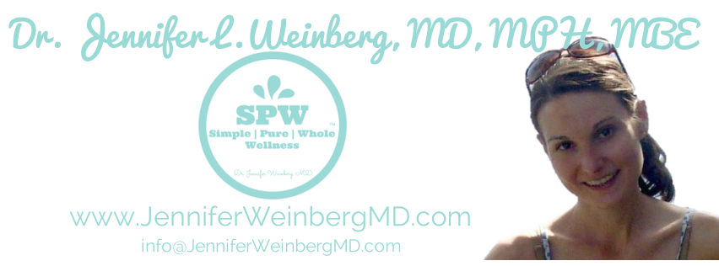
Dr. Jennifer L. Weinberg, MD, MPH, MBE is a Preventive and Lifestyle Medicine Physician trained at the University of Pennsylvania and Johns Hopkins, Author, Consultant, Wellness Expert, Speaker, Interdisciplinary Yoga Instructor and Board Certified Health Coach. As the founder of The Simple Purr WholeTM Wellness Method, Dr. Weinberg is deeply passionate about inspiring others to reclaim a life of ease, vitality and health through her group programs, courses, books and blog. She offers innovative online wellness and education programs for individuals looking for sustainable optimal health as well as professional health communication and editing services and corporate wellness programs. You can learn more at www.JenniferWeinbergMD.com/ or about The Whole Cure on Amazon.

Dr. Jennifer L. Weinberg MD MPH MBE | The Simple Pure WholeTM Wellness Method

www.JenniferWeinbergMD.com | info@JenniferWeinbergMD.com

